4-1-2015 I want to build a virtual machine computer so I can play games on it and not mess up my parent’s computer. I think this will take a couple of days and will be fun!
4-1-2015 To start I need to get some computer programs. Mom says those are also called software. I looked at the 4-H website and it shows some different things I need. I think I need these things:
- VMware Player, I think this lets me play my computer once I build it.
- A virtual machine, this is the computer I’m going to build.
- And another computer to run it on.
- Games for my new computer.
The website provides links to all the resources, except games, that I need to get started. I’m not sure where I’ll get the games.
Oh yeah, I almost forgot. The website is http://www.kansasspacetech.com/computers/
4-1-2015 On the website it shows that there are 3 different types of virtual machine computers I can use. I wonder which one I should get? I wonder what Ubuntu means?
4-1-2015 So I googled server and I found out that a server is:
“A server is a computer that provides data to other computers. It may serve data to systems on a local area network (LAN) or a wide area network (WAN) over the Internet.”
I found this at http://techterms.com/definition/server
I don’t think I want a server. I probably want a desktop.
4-1-2015 I also googled what Ubuntu means. I found a lot of stuff. So Ubuntu means:

“
ubuntu |oǒ'boǒntoō|
Ubuntu is an ancient African word meaning ‘humanity to others’. It also means ‘I am what I am because of who we all are’. The Ubuntu operating system brings the spirit of Ubuntu to the world of computers.
”
I found this at http://www.ubuntu.com/about/about-ubuntu

4-2-2015 This morning I decided to use the Ubuntu Desktop 64bit virtual machine computer. I started downloading it from the Kansas SpaceTech website and I’m still waiting.
4-2-2015 It’s been 2 hours and I’m still waiting for it to finish downloading.
4-2-2015 The downloads done!!! Now lets get my computer going.
4-2-2015 This is a zip file… I wonder how I get it into a virtual machine computer? When I double click on the file it opens up and shows me a bunch of other files. I’m going to put those on the desktop in a new folder called JanesComputer. I took a picture below.
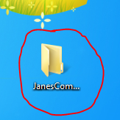
4-2-2015 Mom showed me how to take the picture above using a program called Snipping Tool. When I start up the program the screen turns gray and the mouse changes. I then drag a box around what I want a picture of and it takes the picture and then I can make changes to the picture like circle the folder.
4-2-2015 When I double click on the files nothing happens… I can’t get my new virtual machine computer to start.
I HATE THIS COMPUTER IT WONT WORK!
4-7-2015 Mom did some research to help me get this working. She said I needed the VMware Player program to make the virtual machine run. I guess I forgot.
4-7-2015 I downloaded the VMware Player program and also saw there was a youtube video on how to get my computer working. I watched this video: https://youtu.be/8ezXhqq1M3s It helped a lot.
I also learned that they aren’t called virtual machine computers they are just call virtual machines.
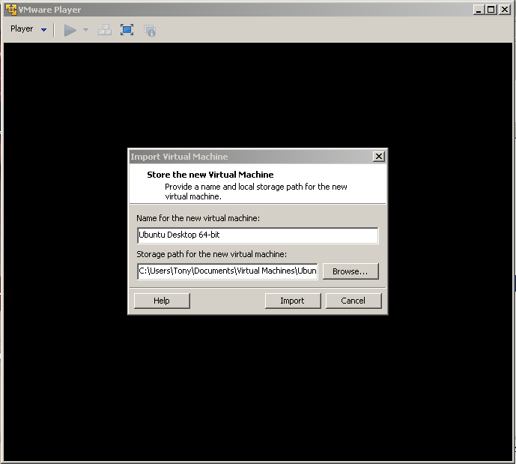
4-8-2015 I got VMware player installed yesterday. It was really easy to do. I downloaded it and clicked on it. Then just clicked next all the way through. Now when I click on my virtual machine it starts working.
4-8-2015 I click the import button and then I click the play button and now I have a virtual machine running on another computer. This is so cool!
4-8-2015 So it takes my virtual machine some time to start up and while its starting up I can’t move my mouse out of the window without pressing the Ctrl and Alt keys.
4-19-2015 Now I have my own desktop! Ubuntu is really weird. It doesn’t have a task bar along the bottom of the screen. To close programs I have to use the x in the top left corner of the screen. I still haven’t found any games on it though.
5-20-2015 I’ve been using my desktop a lot. Mom and I started using the Ubuntu Software Center program so I could get some games to play.
I’m currently playing the game Net. It was free to download and install…
To install it all you have to do is find the game in the software center and click the install button next to it.
7-15-2015 It’s almost fair time and I’m getting my virtual machine ready to go to the fair. To get it ready I did the following:
- I shutdown my virtual machine
- Then I copied it to a USB drive my mom got me
- Then I put all of the forms and instructions on the USB drive.
- Now, I’m going to finish this journal off and put it on the USB drive too.
7-15-2015 CONCLUSION I started off to build my own virtual machine so I could play games and not mess up Mom & Dad’s computer. Sometimes it was hard but most of the time it was fun. I was able to get a virtual machine up and running. Finding and installing games to play was easy. The hard part was getting my virtual machine to work.
Now that I have one working for me I might set up one for my younger brother, if he’s nice to me.

